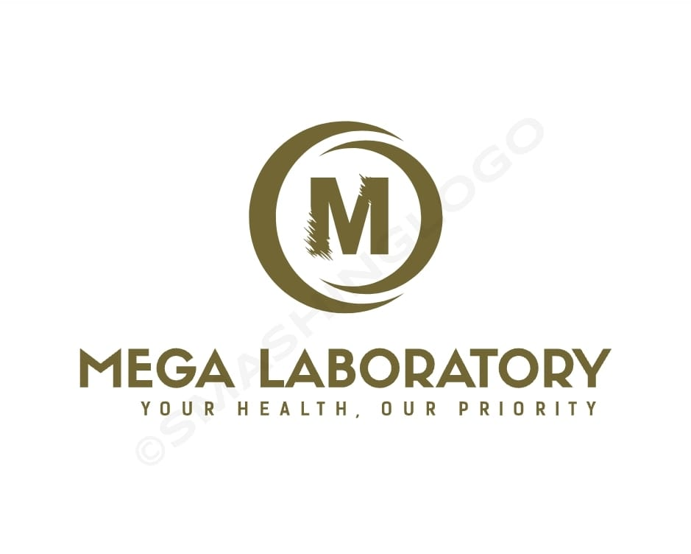

WELCOME TO

**MEGA LABORATORIES**

About MEGA LABs.

Proficiency Healthcare Diagnostics, is an established network of accredited laboratories and radiology centres situated across the entire SL, offering reliable diagnostic solutions for the professional medical community, medical centres, clinics and hospitals.

Our laboratories are furnished with state of the art equipment and instruments, according to the most recent advancements in international laboratory industries.  Combined with modern laboratory information systems, we can confidently identify our patients through digital bar-coding techniques and are able to track and monitor all samples accurately and efficiently

MEGA LABs is a distinctive name in the field of medical laboratory diagnosis. As a provider of innovative laboratory services in different countries, its name reflects advanced technology, uncompromised quality and incomparable customer care.

MEGA LABs possesses high quality infrastructure which is on par with many international quality reference institutions.

Why MEGA LABs?

##### Faster turnaround time (TAT)

We have and we will continue to develop systems dedicated to make sure that there is smooth processing of your requests, bringing you a hassle-free experience from booking a test until the time the results become ready.

##### State of the art technologies

Our laboratory is equipped with the highest level of technology allowing us to perform tests with great sensitivity, specificity and reliability while also increasing the overall number of tests per hour thereby achieving maximal efficiency.

##### Cost effectiveness

At MEGA LABs your health is our top priority. We dedicate ourselves in providing you affordable prices for our services without compromising the quality of our work.

##### Competent and qualified professionals

Our team is composed of highly qualified and competent laboratory professional who are experts in their own field. They are equipped with the right amount of knowledge and skills needed in the performance of their work.

##### Periodic local and international training programs

We always ensure that our methods are based on the latest breakthroughs in technology. That is why, we send our team to our local and international partners for training programs and tie ups for upgrading our services.

##### Weekly internal and external CMEs

MEGA LABs/ MEGA LABORATORIES believes that education is a lifelong process. That is why, we provide Continuing Professional Development (CPD) and Continuing Medical Education (CME) programs which will help not only our own workforce but the entire healthcare community as well.

##### Biggest sample catchment area

We are proud of our never ending list of loyal clients who put their relentless trust in the services we provide. We will continue to do our best to keep the confidence you have with us.

##### Internal and external quality control measures

At MEGA LABs/ MEGA LABORATORIES, quality is and will never be an accident. It is our commitment to ensure that the laboratory results you receive are of the greatest quality.

##### International exposure

With our branches, we will continue to expand our reach as we continue to build more channels for providing you our quality laboratory services.

## OUR VISION

The vision of MEGA LABS is to become the regional leader in clinical laboratory testing and radiology diagnostics with the highest quality standards provided to all our patients and our healthcare provider partnerships.

The vision of MEGA LABS is to become the regional leader and to be a comprehensive center of excellence in the field of medical laboratory diagnosis.

To be a comprehensive center of excellence in the field of medical laboratory diagnosis.

## OUR MISSION

We are on a mission to implement efficient, international best practice in providing world-class diagnostic services at competitive prices, in a timely manner.  Also, to provide consultation, training and technical assistance for all clinical laboratory professionals.

To provide quality, reliable and cost effective medical laboratory services to the people.

### ADVANCED TECHNOLOGY

MEGA LABS have employed advanced technology through the integrated Lab Information System, interfaced with all analysers and state of the art machines to provide automatic, cloud based results that are securely available online.

### TIMELY SUPPORT

Accuracy and efficiency work hand in hand to offer reliable test results, all in very fast turn around times. MEGA LABS is fully supported by a fleet of vehicles to ensure the fast collection and delivery of results across the entire region.

### INNOVATIVE IDEAS

Our extensive and ever growing test repertoire includes molecular and genetic capabilities, that confidently ensures, MEGA LABS remains at the cutting edge of new scientific discoveries in the art of medicine and offers a wide range of test choices to our partners.

### ACCURATE TEST RESULTS

We offer an unparalleled diagnostic service that is available to medical professionals, clinics and hospitals across the entire SL, ensuring that test results are accurate, available on time and that our processes are efficient and reliable.

### EXPERIENCED TEAM

From a highly qualified and experienced team of dedicated professionals to a well organised fleet of couriers and logistic services, we are confident in offering the highest quality diagnostic services available.

## core values

The values of Proficiency Healthcare Diagnostics cascade across the entire group of laboratories and diagnostics centres.  All of the primary care centres, secondary care centres and network of labs have one common set of values to which all members of our ‘family’ adhere to.

##### Quality

MEGA LABs ensures that all of its works are carried out in accordance with recognized standards and best possible quality control measures.

##### Credibility and Accountability

MEGA LABs acts honestly, ethically and impartially at all times and we accept full responsibility for our performances. We ensure that all our reports are accurate and reliable and we uphold our reputation by giving quality and timely reports.

##### Innovation and Collaboration

MEGA LABs constantly seeks innovative ways to enhance the diagnostic precision and patient care to provide value added services to the patients and physicians. MHL strives to work together with collaborative medical institutions around the globe to ensure the availability of unlimited diagnostic test parameters and panels.

##### Center of Excellence

At MEGA LABs we aim to become the most reputed and trusted referral laboratory in every aspect of medical laboratory diagnosis.

Corporate Social Responsibility

MEGA LABs aims to make a difference. Not only that we want to make a difference in ourselves but we also want to make a difference in our community as a whole.

We have always believed that it is also our shared responsibility to become active mediators of positive change to the communities in which we work and live.

As a company, we uphold our values based on three important approaches to corporate social responsibility—community mindedness, environmental conservation and unity in diversity

We are committed to conducting our business in a socially responsible fashion, while always prioritizing the needs of our clients, staff, partners in business and other stakeholders.

We consider our reputation, combined with mutual trust and confidence, as one of our company’s most valuable assets and we will continue to strive in maintaining the highest ethical standards in all of our endeavors.

For inquiries or partnerships regarding our programs and activities pertaining to our corporate social responsibility, you may leave us a message 10000000 VIP.